**Hackathon Project Phases Template** for the **AutoSage App** project.

Hackathon Project Phases Template

# Project Title:

**AI Personilized Email Generator**

# Team Name:

TEAM 1519253488

# Team Members:

* JAMBili NAVEEN
* BRAHMANAPALLY AKSHAY KUMAR
* VARUN LAXMI NARASIMHA DEEKONDA
* BODDU NIKHIL
* GAJAM BHANU CHANDER

# Phase-1: Brainstorming & Ideation

### Objective:

To generate diverse creative and innovative ideas by fostering open thinking collaboration and problem solving.The goal is to explore multiple persectives , challenge assumptions ,and develop actionable solutions for specific challenges or opportunities

**Key Points:**

## Encourage creativity:

**. stimulate out-of-Box thinking to generate unique ideas**

#### Divergent Thinking:

* + Explore a broad range of possibilities before narrowing down

#### Collabration and inclusivity:

* + **Involved diverse perspectives for richer ideation**

#### Problem-solving:

* + Address specific challenges with innovative solutions

# Phase-2: Requirement Analysis

### Objective:

**Purpose: The goal is to generate personalized email content for various purposes, such as marketing campaigns, customer outreach, internal communications, etc.**

**Target Audience**: Who will be using the generator? Marketers, customer service teams, or even automated systems?

**Scope**: The system should automate personalization for emails while retaining a conversational, human-like tone.

### Key Points:

#### Automated Personalization:

* + Generate tailored email content based on recipient data (name, preferences, behavior, etc.).

#### Increased Engagement:

* + Deliver relevant, engaging messages to boost open rates, click-through rates, and user interaction.

#### Scalable Email Campaigns:

* + Enable the creation of large volumes of personalized emails quickly and efficiently.

#### Higher Conversion Rates:

* + Drive conversions with highly targeted offers, recommendations, and calls-to-action**Brand Consistency**:
  + Maintain a consistent brand tone and messaging in all personalized emails.

# Phase-3: Project Design

### Objective:

The key goals to ensure the successful development and deployment of the system. These objectives help shape the project and its outcomes, providing clear guidance on what the system should achieve from a design and technical perspective.

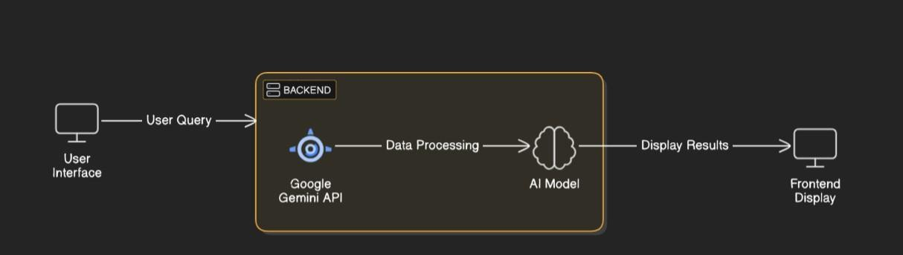

### Key Points:

1. **System Architecture:**
   * The **System Architecture** for a **Personalized Email Generator** defines the structure of the application, the components involved, how they interact, and how data flows through the system
2. **User Flow:**
   * **It describes the sequence of actions a user takes from the start to the completion of generating, previewing, and sending a personalized email. It outlines the steps users follow through the interface, detailing the interactions with each component.**
3. **UI/UX Considerations:**
   * The goal is to create an intuitive, efficient, and engaging user experience that makes the process of creating, customizing, and sending personalized emails as smooth as possible. Here are the key UI/UX considerations for such a system:

# Phase-4: Project Planning (Agile Methodologies)

### Objective:

**Agile Methodologies** aim to provide a clear framework for delivering the **Personalized Email Generator** efficiently, iteratively, and collaboratively. Agile focuses on flexibility, continuous feedback, and incremental delivery, ensuring that the product evolves with changing requirements and user feedback. The primary goal is to maintain a high level of responsiveness to both internal and external changes throughout the project lifecycle.

|  |  |  |  |
| --- | --- | --- | --- |
| **Objective** | **Description** | **Steps/Actions** | **Outcome** |
| **1. Define Clear and Prioritized Product Backlog** | Develop a prioritized list of features, enhancements, and tasks based on business value and user needs. | * Gather requirements from stakeholders. * Break down features into actionable user stories. * Prioritize backlog. | A clear, actionable backlog for the development team to follow. |
| **2. Deliver Working Software in Iterations (Sprints)** | Break down work into smaller, manageable sprints for incremental delivery. | * Define sprint length (1–4 weeks). * Select high-priority user stories. * Break stories into tasks. | Functional features delivered at the end of each sprint that can be tested and reviewed. |
| **3. Continuous Collaboration with Stakeholders** | Ensure ongoing communication and feedback from stakeholders to refine the product. | * Hold regular sprint reviews. * Engage with stakeholders frequently. * Share progress transparently. | A product that evolves with stakeholder feedback, ensuring it meets user and business expectations. |
| **4. Promote Flexibility and Adaptability to Changing Requirements** | Maintain the flexibility to adapt the product to changing business or technical requirements. | * Regular feedback loops. * Re-plan priorities based on feedback. * Continuously refine the product backlog. | A product that can adapt to new requirements and market changes. |
| **5. Prioritize Quality and Continuous Testing** | Ensure high-quality deliverables through automated and manual testing. | * Integrate automated tests. * Perform code reviews. * Carry out user acceptance testing (UAT). | High-quality features with minimal bugs and issues upon delivery. |
| **6. Set Clear Sprint Goals and Achieve Measurable Success** | Define and focus on clear goals for each sprint to ensure progress is measurable. | * Define sprint goals based on high-priority features. * Align goals with business objectives. | Clear, measurable success criteria for each sprint. |

### Sprint Planning with Priorities

**Sprint 1 – Setup & Integration (Day 1)**

The first sprint is focused on setting up the development environment, configuring tools, and integrating essential systems for the **Personalized Email Generator** project. This sprint lays the foundation for future development, ensuring that all necessary tools, systems, and frameworks are in place to begin building the core functionality.

### Sprint 2 – Core Features & Debugging (Day 2)

In this the focus will be on adding more **core features** to the **Personalized Email Generator**, specifically around enhancing the **email template editor**, **personalization**, and **debugging** the initial setup. The goal is to make the tool more functional and address any issues identified during the first sprint.

### Sprint 3 – Testing, Enhancements & Submission (Day 2)

In **Sprint 3**, the focus will shift to **testing**, **enhancing features**, and preparing for **submission**. This sprint is about refining the product by fixing bugs, enhancing user features, ensuring stability, and preparing it for final submission or review

# Phase-5: Project Development

### Objective:

The **Project Development Objectives** outline the key goals and deliverables that should be achieved during the development of the **Personalized Email Generator**. These objectives guide the team through the process and ensure that the end product aligns with user needs, business goals, and technical requirements.

### Key Points:

1. **Technology Stack Used:**
   * **Frontend:** It is the user-facing part of the **Personalized Email Generator**. It involves building the interface through which users will create, personalize, and send emails. The frontend needs to be intuitive, responsive, and provide real-time interaction with the backend for generating dynamic emails
   * **Backend:** It is responsible for handling business logic, user authentication, data storage, and communication with third-party services for sending emails. The backend ensures that the system functions seamlessly, providing users with dynamic and personalized content while maintaining security, scalability, and performance.
   * **Programming Language: Python**
2. **Development Process:**

* The **development process** for creating the **Personalized Email Generator** follows best practices in modern software engineering, ensuring the system is scalable, maintainable, and user-friendly. We adopt **Agile methodologies** for an iterative and flexible approach, allowing continuous improvements, feedback integration, and timely delivery

1. **Challenges & Fixes:**

* It involves overcoming several challenges in various areas such as system architecture,

user experience, email deliverability, scalability, and integration with third-party services. Below are some of the key challenges encountered during development and their respective fixes.

## Phase-6: Functional & Performance Testing

### Objective:

* It is to ensure that the application performs as expected under both normal and extreme conditions, meets all functional requirements, and delivers a smooth user experience. The goal is to identify and resolve issues related to functionality, usability, and performance before the product goes live.
* **Functional Testing**: Focuses on verifying that all the core features and user requirements are working correctly.
* **Performance Testing**: Assesses how well the system handles load, concurrency, stress, and scalability, ensuring it can handle peak usage without performance degradation.
* **Tools/Frameworks**: Lists the tools used for specific testing types, which help automate and streamline the testing process.

# Final Submission

1. **Project Report Based on the templates**
2. **Demo Video (3-5 Minutes)**
3. **GitHub/Code Repository Link**
4. **Presentation**